

**Lab # 08**

**Student Name: Muhammad Hussain**

**Roll Number: BIT-23F-023**

**Section: A**

**Subject: Artificial Intelligence**

**Department: BS Information Technology**

**Task: 01:**

Write a Python function that takes a number as input and returns the sum of its digits.

**Code:**

def sum_of_digits(number):

    # Convert the number to an absolute value in case it's negative

    number = abs(number)

    # Calculate the sum of the digits

    return sum(int(digit) for digit in str(number))

# Example usage

num = 123456789

print(f"\n The sum of the digits of {num} is: {sum_of_digits(num)}\n")

**Output:**

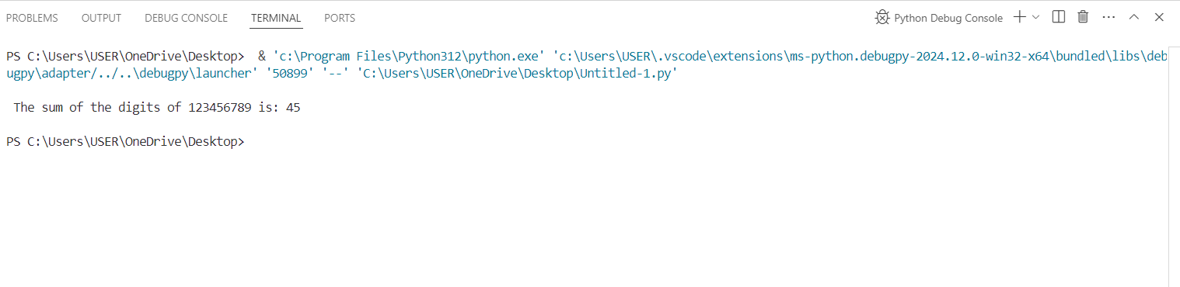

**Task: 02:**  
 Write a Python function that takes a sentence as input and returns the number of words in it.

**Code:**

def count_words(sentence):

    # Split the sentence into words using whitespace and count the words

    words = sentence.split()

    return len(words)

# Example usage

sentence = "My self Muhammad Hussain From Sukkur."

print(f"\n The number of words in the sentence is: {count_words(sentence)} \n")

**Output:**

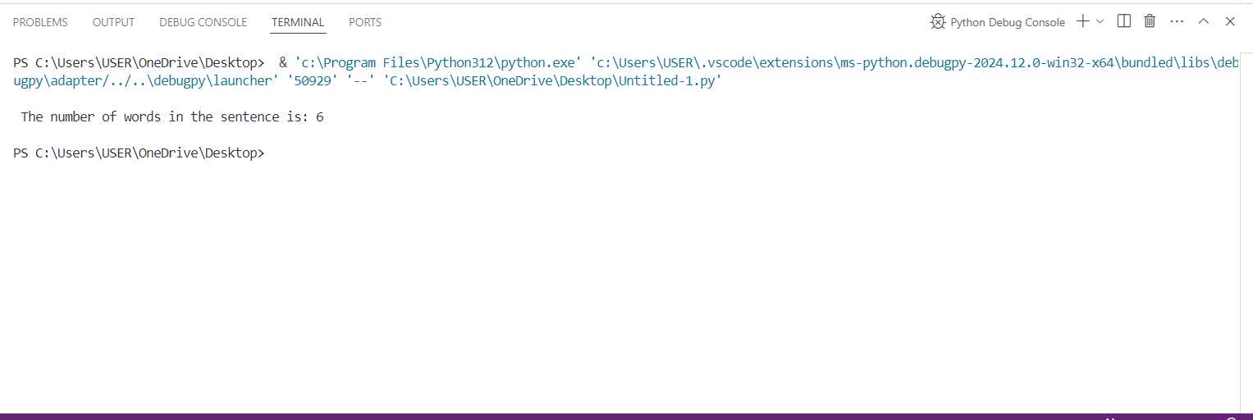

**Task: 03:**

Write a Python function that takes an integer and returns whether the number is even or odd.

**Code:**

def is_even_or_odd(number):

    return "Even" if number % 2 == 0 else "Odd"

# Example usage

num = 20

print(f"\n The number {num} is {is_even_or_odd(num)}.")

num = 10

print(f" The number {num} is {is_even_or_odd(num)}.\n")

**output:**

